Daniel Williamson, Austin Torrence

CS126 Lab 4

Grade Calculator

October 1, 2015

1)

For this lab we had to create a program that would take an individual’s grade that they received on their homework, quizzes and tests and give it a letter grade. And we had to produce a final score for the ladder. We do this by defining various functions to calculator their average score across multiple assignments. Then based off their score assign them a letter grade. And finally average the weighted scores across the three graded categories and assign them a final grade as a letter grade and percent.

2)

Planning was a bit tricky, we had to begin by making lists of the scores they received for each the homework, quizzes and tests. We also had to make lists for the max points possible for each of the three and their weighted average for the final grade. Once made, we began to define our functions using the def command. We created three functions percentage_per_category, which gave us a percent score, the letter_grade function, which took the percent score and assigned it a letter grade, and lastly weight_score function to take the percentage, weigh them, which created our final score. In the end we needed to print out letter and percent scores, which we rounded, for homework, quizzes, tests and the final score.

3)

1st photo – our code

2nd photo – continuation of our code

3rd photo – running our code

4th photo – pep8

Implementation went smoothly once we understand what was needed. We did exactly as we planned and began to make lists. And using those lists to run through our defined functions. Then in the end printing the homework, quiz, test and final grades.

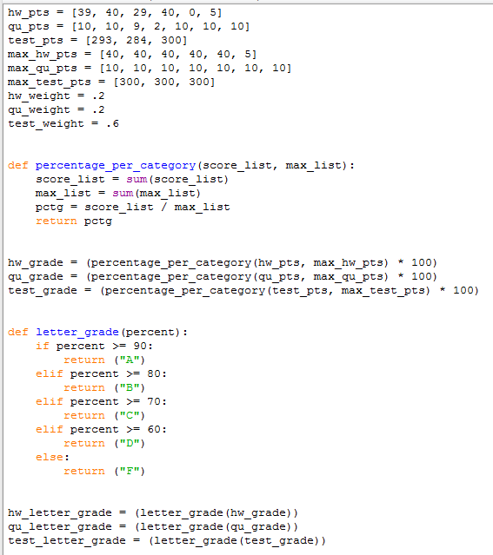

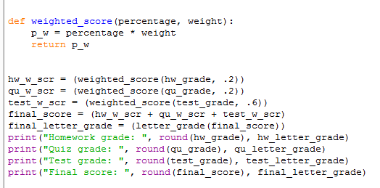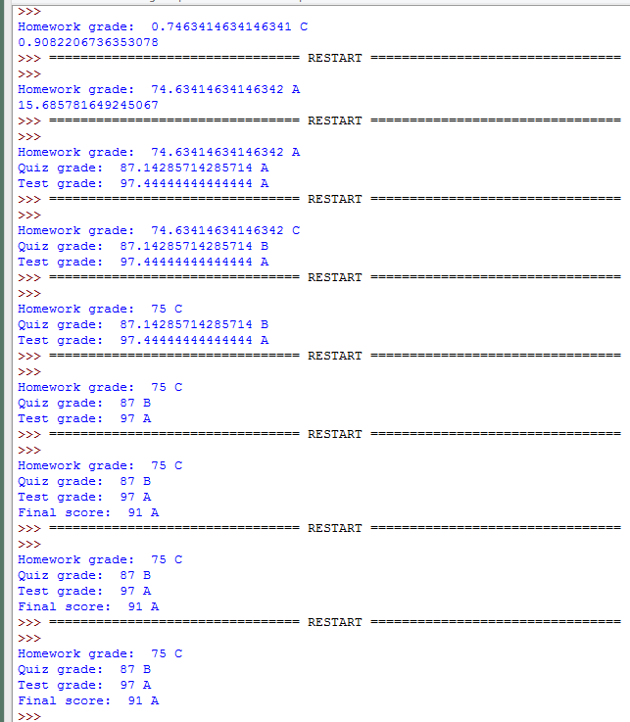

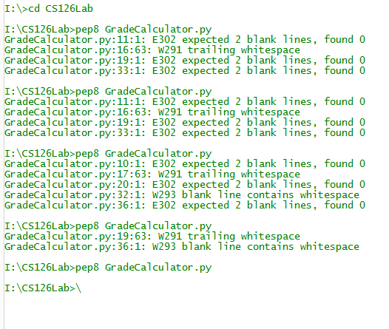

4)

This program was designed to allow the user to calculate his or her grade by inputting their scores into our lists to determine their letter grade and final grade. We defined functions to do this. In order to make this better perhaps we could create a way to have the user input there grades for all assignments, put those into our lists and then prints out a grade. We also could have made it so there are more assignments in the listings. Some of the key features were the def/return commands to pass our lists through. And as always there most likely is a way to condense some of the code.